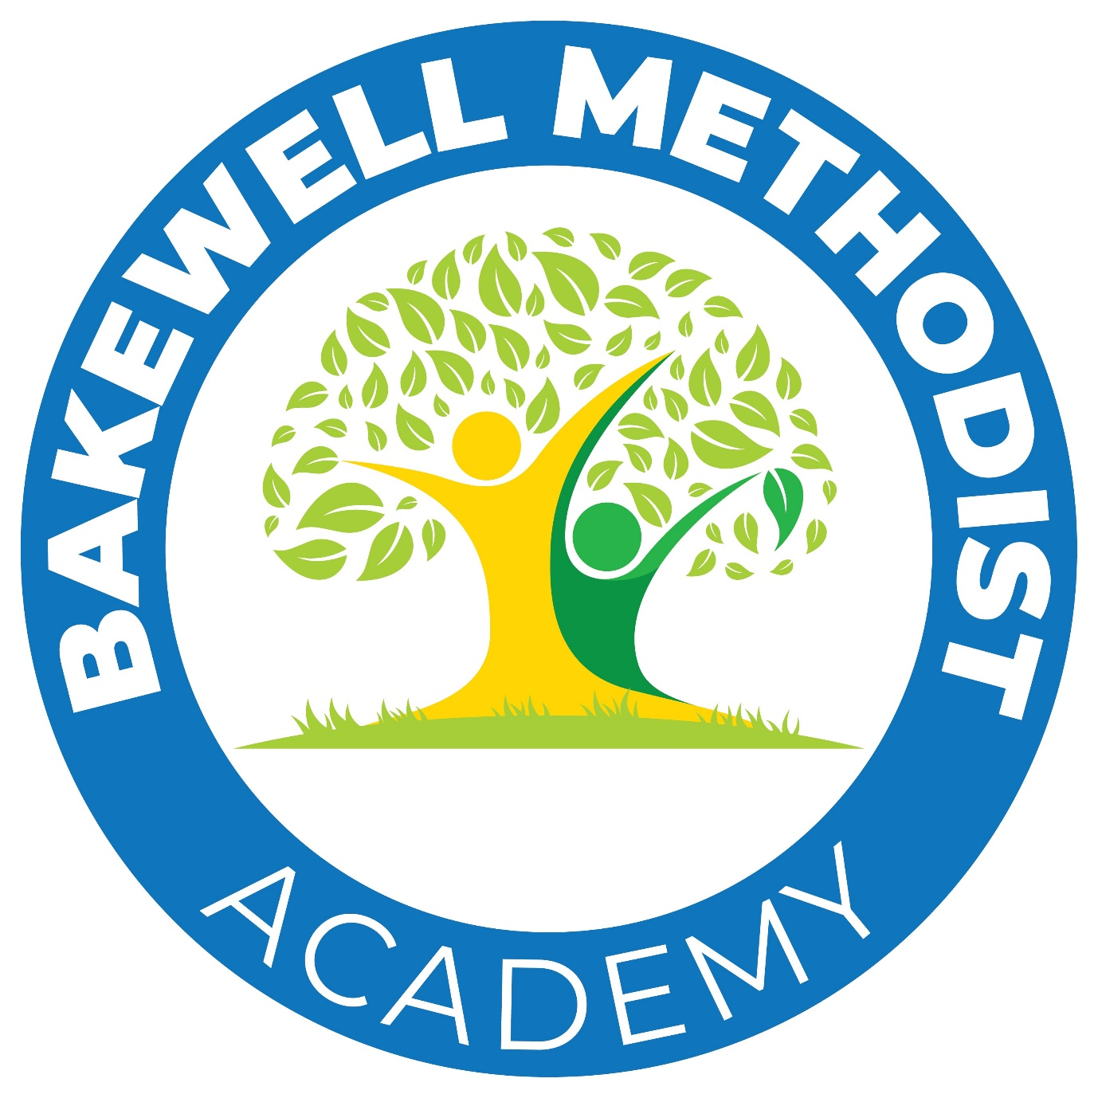
Bakewell Methodist Academy
Stoney Close
Bakewell
DE45 1FR

www.bakewellmethodistacademy.co.uk
01629 812389
info@bma.epworthtrust.org.uk
Headteacher, Mrs Sarah Owens
Head of School, Catherine Donovan

3rd June 2026

Dear Parents and Carers

We are very excited about our end of year whole school production. This year the children will be performing ‘Oliver with a Twist’.

We will be putting on 2 performances on Thursday 16th July. An afternoon performance will take place at 1.45pm and an evening performance at 6.00pm. We would recommend bringing very young children along to the 1.45pm performance.

Tickets are currently limited to 3 per family per performance (6 in total but a maximum of 3 per performance) Children over the age of 2 will require a ticket. Tickets are free of charge, but we do need you to book them via parent pay before the 30thJune. Any remaining tickets after this date will be given out on a first come first served basis.

Please log onto parent pay to request the number of tickets you require for each performance. Tickets will be available on parent pay in the next 24 hours.

We look forward to welcoming you to our show!

Warmest Wishes

Catherine Donovan
Head of School

