
Year 4 Term Summer Term 1 Overview
Week 1 | Week 2 | Week 3 | Week 4 | Week 5 | Week 6 | Week 7
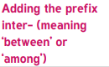 | 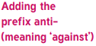 |  | 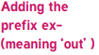 | 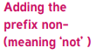 | 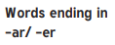 | Review Week
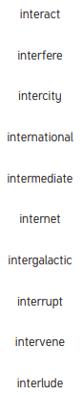 | 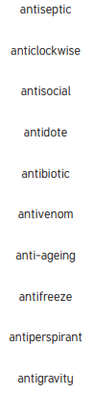 | 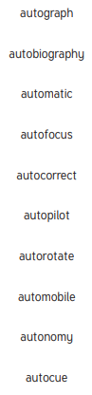 | 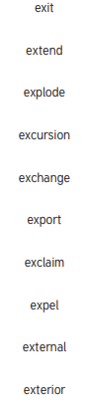 | 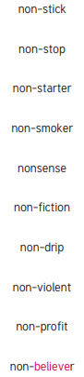 | 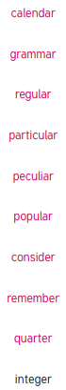 | Assess & Review

