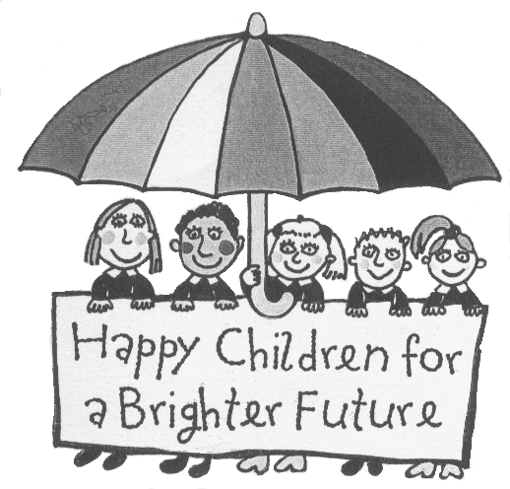
Bakewell Methodist Junior School

Anti-bullying policy
(Written in a child-friendly way.)

Our Values and Beliefs
Here at Bakewell Methodist Junior School we believe that:
- Everyone has the right to feel safe and happy.
- Bullying is unacceptable.
- All children have the right to feel listened to and respected.

Several Times On Purpose
It is important to remember that one off incidents and friendship fall outs are not bullying, bullying is a repeated and deliberate behaviour which is meant to hurt and upset someone.
If you feel you are being bullied,
tell someone.
Types of Bullying
There are many different types of Bullying such as:
Physical— Hurting someone by hitting, kicking, spitting etc.
Emotional— Isolating someone or intimidating them, spreading rumours etc.
Verbal— Threatening and calling someone names.
Racial/homophobic— bullying someone because of their skin colour or race. Calling someone ‘Gay’ or ‘Lesbian’ as a way of hurting them.
Cyber Bullying—this is bullying someone over the internet, social networking sites or via text.
How can we prevent bullying in our school?
We can all help prevent bullying by:
- Keeping to our Golden Rules.
- Promoting a positive ethos in our school by helping others when they are in need, being kind, friendly and helpful and showing respect to all members of our school community.
- Taking part in Circle Time, Anti-Bullying Week & Jigsaw & PHSE lessons.

Dealing with and Resolving Bullying
We take all incidents of bullying very seriously and all reports of bullying are dealt with by the Head Teacher and Senior Teacher.
Where bullying has occurred, we will follow the school procedure:
- A statement will be completed by a member of staff (either your Class Teacher, or another adult that works at the school).
- This will be investigated by the Headteacher who will log the incident in the behaviour log .
- All parents will be told in all proven cases of bullying.
- The Head and Senior teacher will decide on appropriate action to stop the bullying and help the child who has been bullied.

Remember!
Do tell someone if you’re being bullied.
Don’t copy the behaviour of the bully.
Do try and tell the bully to stop.
Don’t be a bystander - if you see bullying happening in school, report it.

Together, we can STOP bullying

