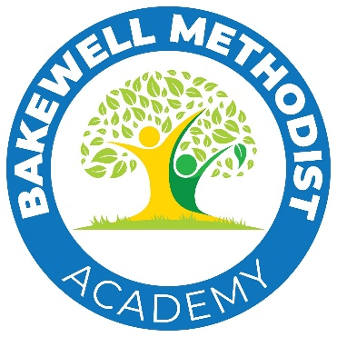

Bakewell Methodist Academy
Stoney Close
Bakewell
DE45 1FR

www.bakewellmethodistacademy.co.uk
01629 812389
info@bma.epworthtrust.org.uk

Headteacher, Mrs Sarah Owens

30th April 2025

Dear Parents and Carers of Y2 Children

Welcome to our school

Over the next few weeks, I will visit Bakewell infant School to start to get to know your children a little better in preparation for transition in September. I wanted to let you know about some events we have planned for you and your children.

Meeting for parents- Wednesday 4th June 4pm
You are invited to a short meeting for parents where you can meet your child’s new teacher, have a tour of the school and ask any questions you may still have. Please bring your child and their sibling is you wish.

Changeover Day-Wednesday 2nd July 8.30am-3.30pm
Children can arrive at 8.30am and parents can bring the children to the playground, where you will be met by Mrs Donovan. They may wear their infant school uniform and will need to bring a water bottle and a packed lunch if that usually have one. If they usually have a school meal, this will be provided as normal. The children will be brought to the school gate by their teacher at 3.30pm

Y2 Forest Schools Day- Friday 18th July 8.30am-3.30pm
Children may arrive from 8.30am and can be collected at 3.30pm. Lunch arrangements as above.
Children should wear clothing suitable for a day outdoors. If the weather is sunny, children will need a sun hat, suncream (applied before school), cover for arms and legs outdoor shoes-trainers are fine. If the weather is cold and wet, children will need full waterproofs and outdoor shoes. Children should bring some indoor shoes to change into for indoor activities and lunch.
Forest school activities will be led by Level 3 trained Forest School leaders and we may light a fire at the end of the day. All other activities will take the form of crafts and games. If you have any questions about his please just get in touch.

Kindest regards

Sarah Owens

