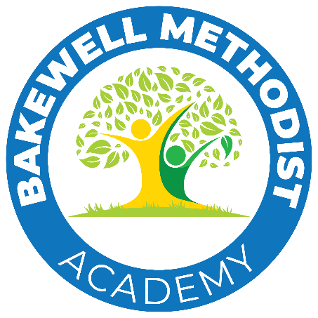
Determined admission arrangements for 2025-26
Bakewell Methodist Academy
2024 Version 1

Last Reviewed | February 2024
Reviewed By (Name) | Governors
Next Review Date | February 2027
Version produced February 2024 | New release.

Contents
Admission number 40 2
Tie-Breaker 2
Notes 2
Child’s Home Address 3
Late Applications 3
Withdrawing an offer 4
Children of multiple births 4
Waiting Lists 4
Admissions of children of outside their normal age group 4
In-Year Admissions 4
Admissions Appeals 5

Bakewell Methodist Academy is part of the Epworth Education Trust. As an academy we are required to set and publish our own admission criteria.
Admission applications are managed through the Derbyshire Co-ordinated Admissions Scheme and are in line with the Derbyshire Admission arrangements for community and voluntary controlled schools.
If your child was born between 1 September 2017 and 31 August 2018 and is in their final year at infant school they will need to transfer to junior school in September 2025.
Parents' guide to primary admissions - Derbyshire County Council

Admission number 40
Where the school receives more applications than places available, the following oversubscription criteria will be applied once places have first been allocated to pupils who have a statement of special educational needs or education health and care plan which names the school:
- Looked after children and children who were looked after but ceased to be so because they were adopted (or became subject to a residence order or special guardianship order). This includes children who appear (to the admission authority) to have been in state care outside of England and ceased to be in state care because of being adopted.
- Children living in the normal area (see note 1) served by the school at the time of application and admission who have brothers or sisters (see note 2) attending the school at the time of application and admission.
- Children living in the normal area (see note 1) served by the school at the time of application and admission.
- Children not living in the normal area (see note 1) served by the school but who have brothers or sisters (see note 2) attending the school at the time of application and admission.
- Other children whose parents have requested a place.

Tie-Breaker
Where there are more children in one particular criterion than the number of places available, places will be allocated to the children who live nearest to the school. The distance will be measured in a straight line from the child’s home address to a central point at the school using a Geographical Information System (GIS) which is based on ordnance survey (see note 4)
If we offer the last place available at a school to one of twins (or triplets, or so on), our policy is to admit the other twin or triplets too.
Occasionally, the distance from home to school is the same for more than one child (for example, if more than one child lives in the same block of flats). In these cases we will use a system to randomly pick who will be offered a place.

Notes

Note 1:'Living in the normal area' is defined as the child having settled full-time residence in a property which is the child's only or main residence. Documentary evidence including proof of actual permanent residency at the property concerned may be required for example council tax or utility bills, sale or rental agreements.

We reserve the right to withdraw any offer of a school place which has been obtained as a result of misleading or fraudulent information.
Please note a place cannot be guaranteed for any child, even those living in a school’s normal area (or in the Eckington area, attending a contributory primary school).
Note 2: The term brother or sister includes:
(a) a half brother and/or a half sister
(b) a legally adopted child being regarded as a brother or sister
(c) a step-brother and/or step-sister residing in the same family unit
Note 3: Parents seeking a place at a voluntary controlled school on religious grounds should obtain a letter of support from a minister, priest or pastor or religious leader if the child is a member of another Christian church or world faith, who knows the family and can confirm regular attendance at public worship.
Regular worship is defined as attendance at public worship at least once a month.
This must be included with the application. Where appropriate baptismal certificates should also be supplied. Exceptional circumstances will be considered if explained in writing by the relevant religious leader.
Note 4: The Geographic Information System (GIS) will be used to measure the straight line distance. This measurement is taken from the postal address file, normally the house front door.
For schools, the grid reference is normally taken from the postal address file and will normally be the centre of the school.

Child’s Home Address
The home address used for school admission purposes is the address where the child is residing at the time of both application and admission. Where an application includes more than one address due to shared parental responsibility, we will use the address where the child resides for most of the school week (where they usually or mainly sleep between Monday and Friday).
Parents and carers are required to submit full details with supporting information to enable us to determine which address to use for the purpose of admission.
Where parents provide evidence that the child resides equally at both addresses during the school week, and we are unable to reach a decision based on the information received, parents will be asked of the mutually agreed address to be used for the purpose of school admissions.

Late Applications
A place cannot be guaranteed for any child whose parents apply after the closing date. This includes a child who moves into a school's normal area after that date.
In situations where late applications are received and the school's admission number has been reached, but subsequently a place becomes available - if choices need to be made between normal area applications, those children living nearest to the school (measured by the nearest available route) will be given preference.

Withdrawing an offer
For admission procedures to be fair it is important that all the information you provide is accurate. If we find that any information provided by parents is misleading or fraudulent, we reserve the right to withdraw any offer of a school place.

Children of multiple births
Where the final place to be allocated within the Published Admission Number would separate children of multiple births a place(s) will also normally be offered to the other child / children.

Waiting Lists
Places may become available at a school after the offer date. We will:
- Put all children who we refuse a place on the waiting list for the school;
- Keep the list in priority order, decided by the oversubscription criteria for the school only;
- Offer any place that becomes available to the next child on the waiting list; and
- Maintain the waiting list until the end of the autumn term.
We cannot take into account the length of time a child’s name has been on the waiting list, only the admission criteria for the school. This means that your child’s position on the list may change if another parent asks to be put on the list and their child has higher priority in the oversubscription criteria.

Admissions of children of outside their normal age group
Parents may seek a place for their child outside of their normal age group, for example, to a higher year group if the child is gifted and talented or to a lower year group if the child has experienced problems such as ill health or has special needs not covered by an Education Health and care plan.
If parents wish to request that their child be educated outside the normal age group they need to gain approval from the admission authority of the school. For further information on applying for admission of children outside their normal age group, please see he following links:
- Education outside the normal year group - Derbyshire County Council
- Admission of children outside their normal age group - Derbyshire County Council

In-Year Admissions
Please click on the link for information on how to transfer schools: Changing schools during the school year - Derbyshire County Council

Admissions Appeals
Parents have the right to appeal an admission authority decision. Details for appeal are available on the Derbyshire council website, including the date by which the appeal must be submitted and the timetables for organising and hearing admission appeals.
Link to appeals: School admission appeals - Derbyshire County Council

